**CS 1632 – Deliverable 2: Unit Testing Ruby Rush**

Name: David Brush

Git Username: BaLLiN-BrUsH

**Summary:**

*ruby_rush.rb* – the main driver for this program

*check_num_args.rb* – is called from ruby_rush.rb to verify that the number of arguments and type of arguments are correct

*simulator.rb* – initializes the random number generator with the given seed, manages the number of prospectors and the number of turns each prospector is taking

*prospector.rb* - initializes a single “rubyist” that has a variety of functionality such was search_for_rubies(), next_loc(), and show_findings()

**Issues:**

In regards to creating the main program itself, I came across several issues during development. One of the issues was determining how to use the user entered seed and figuring out if it was working properly. When I first implemented it, I was getting different results for the same input until I realized that the random number generator should be created before the simulation begins and passed to each of the prospectors.

In regards to creating unit tests, there were definitely parts of the program that were very difficult to try to test. One of the issues was trying to come up with a way to validate that the first argument (args[0]) was a valid integer. I ended up using assert_kind_of and comparing the value to the Integer class. Unfortunately, there is one line in check_num_args that, after running the SimpleCov in all_tests.rb, still proceeds to throw an error that the line was missed when all cases where covered.

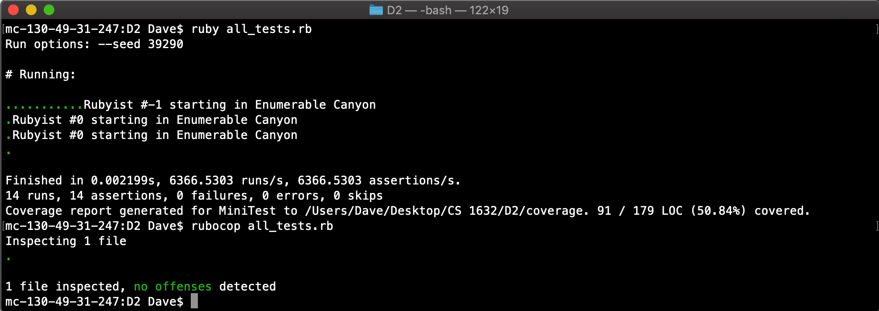

I believe most of the coverage that I actually test is not being verified by SimpleCov and I was not able to start developing the unit tests for prospect_test.rb. The program should work accordingly outside of all the unit testing.